exercise 7:
- SELECT f_name, l_name FROM employee_data ORDER BY age ASC LIMIT 5; 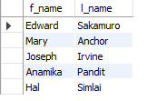
- SELECT * FROM employee_data LIMIT 5 OFFSET 9;
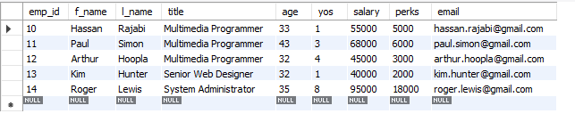
- SELECT f_name, l_name, salary FROM employee_data ORDER BY salary DESC LIMIT 1;
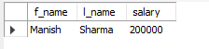
4. 